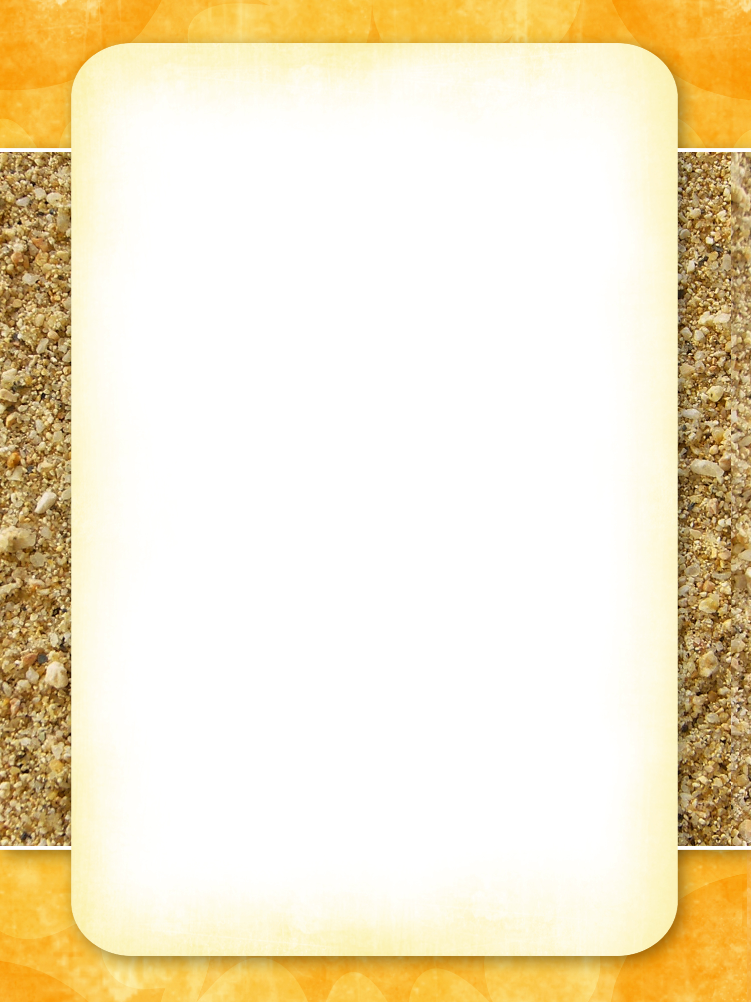

Bar Menu
Happy Hour Every Day 6-7pm - All Drinks 50% Off the Marked Price

Beers
On tap Schooner Middy
- Victoria Bitter, Hann Super Dry or XXXX Gold $5.00 $4.00
Bottles (375mm) Bottle (375ml)
- Boags Premium, Crown Larger or Cascade Larger $6.00

Wine Bottle Glass
- Mad Dog Savion Blanc 1999 (Hunter Valley) $25.00 $7.00
- Fifth Leg Chardonnay 2014 (Tasmania) $27.00 $8.50
- Cloudy Bay Riesling 2013 (Marlborough NZ) $30.00 $9.00

Spirits Nip With Mixer
- Bundaberg Rum, Smirnoff Vodka or Johnny Walker Red $5.00 $6.75
- Johnny Walker Black, Canadian Club, St Freds Cognac $9.00 $11.75

Cocktails
- Slammers Delight (The Specialty Drink Rum, Vodka & Fruit) $11.00
- Bloody Mary (Vodka, Tomato Juice, Lime & Worcestershire Sauce,) $11.00
- Vodka (Irish Cream, Kahlúa & Grand Marnier) $11.50
- Blue Moon $12.00

Item
A brief description of the dish.

